

Year 8 Science. Assessment |  | Term 4 2016
Student Name
Year Level | Year 8
Class | SCI082D |  | Handout Date: | Week 1
Teacher | Mr Turner |  | Rough Draft Date:
Unit Name | Energy |  | Due Date: | Week 3
Task | Extended Experimental Investigation – Calculating Elastic Potential Energy
Investigation question | How much Elastic Potential Energy is stored when you stretch an elastic band?
Assessment Technique | Scientific Report
Assessment conditions | Instructions:  Students must complete the details on this cover sheet.  Any students suspected of cheating will be referred to the Head of Science  - Students can complete the experiment in groups of three, but must write an individual report.
Specific Assessment requirements | Literacy  Medium. | Numeracy  High | ICTs  Low | Other
Score | /50 | A | B | C | D | E
Score | /50 | A⁺ ≥47½ A ≥42½ A⁻ ≥40 | B⁺ ≥37½ B ≥35 B⁻ ≥32½ | C⁺ ≥30 C ≥25 C⁻ ≥ 22½ | D⁺ ≥20 D ≥15 D⁻ ≥ 12½ | E⁺ ≥10 E ≥5 E⁻ <5
Criteria |  |  |  |  |  | Grade
Science Enquiry Skills
- Analyse patterns and trends in data, including describing relationships between variables and identifying inconsistencies
- Use knowledge of scientific concepts to draw conclusions that are consistent with evidence
- Evaluate conclusions, including identifying sources of uncertainty and possible alternative explanations, and describe specific ways to improve the quality of the data
- Communicate scientific ideas and information for a particular purpose, including constructing evidence-based arguments and using appropriate scientific language, conventions and representations

Differentiation – Adjusted Assessment Conditions
☐Assignment broken into stages | ☐Collaborative effort | ☐Extension
☐Length of task/time altered | ☐Teacher/Aide assistance | ☐Assessment method altered
☐Task simplified | ☐Use of technology | ☐Other
☐Use of reader/scribe | ☐Print/Diagrams enlarged | ☐Other
Acknowledgement of assessment responsibility |  | Student Signature:
I understand what I need to do for this assessment.  I understand the consequences of plagiarism/cheating and confirm this is my own work. |  | ………………………………………  Date: ………………………………

Elastic Potential Energy
Extended Experimental Investigation

READ THIS BEFORE YOU START | Complete the sections of this booklet as indicated.  This task is designed to help you develop skills in several key areas of report writing. These skills will be essential to being a successful student in latter tears of Middle school, and are very important in Senior school science subjects. Specifically this task is designed to help you practice:  - the application of simple maths formulas to calculate data  - Scatter graphs and trend lines for data  - Writing the analysis section of a science report.  Each section of the report has been allocated marks, and these have been shown in the left most column of the report. In this column is some additional help or advice in completing the tasks.
Investigation Question | How much energy can be stored in an rubber band when it is stretched?
Introduction  Several paragraphs explaining all the theory necessary for a reader to undertand the science you present in this report.  - 1st Section  This section explains why this experiment is important. Why study elastic potential energyin a lab… how does this help us in real life situations?  - 2nd Section  Provide an explanation of all of the theory you will use in your investigation. This will include (but is not limited to) acceleration due to gravity, potential energy, Kinetic energy, Law of conservation of energy.  - 3rd section  This should be a description of how you will do your investigation – that is describe what you will do to answer the two Investigation questions posed on the front page.  - General advice – do not use “you”, “us”, “we”, “they” or other personal pronouns  - At the end of your introduction list any website addresses you have used  /4 | Introduction:  Elastic potential energy is the energy stored in elastic materials as the result of their stretching or compressing. Elastic potential energy can be stored in any material which is elastic in nature. The most common use of Elastic potential energy is when springs and other elastic objects are used to store elastic potential energy to be converted later into kinetic energy. A very simple example of this is a slingshot loaded with a small ball. When the rubber band in the slingshot is pulled back, it stores the energy used to pull it back as elastic potential energy. When the rubber band is released, the energy is released and transferred to the ball as kinetic energy. A more complex example is the suspension of a motor vehicle - the spring or hydrolics absorbs the Kinetic energy and releases it slowly – making your ride smoother. There are many simple applications of machines which uses elastic potential energy as a way of storing or transferring enrgy.  The amount of elastic potential energy stored in a slingshot or a suspension system is related to the elasticity of the device. The more it can be deformed (stretched or compressed), the more elastic potential energy it can store. The elastic potential energy (E_{PE}) stored in a spring, rubber band or any stretchy material can be calculated in a few simple steps.  The equation for calculating elastic potential energy in an elastic object is material can be calculated in a few simple steps. The equation for calculating elastic potential energy in an elastic object is: elastic potential energy in an elastic object is:  E_{(PE)} = ½ k d²  Where E_{(PE)} is elastic potential energy, and…  - k is the spring constant  - d is how far the spring or rubber band is stretched from its resting position.  The spring constant (k) is a number used to describe the “elasticity” of a spring or rubber band – it has to be measured for each individual spring or rubber band. Once the spring constant (k) is measured, it can be used to work out how much E_{PE} is stored in the object when it is stretched over any distance (d). The spring constant can be determined using a newtons scale (measures Force, F) and the formula:  k = F x d  In this investigation the spring constant of several rubber bands will be determined. This value will then be used to calculate the elastic potential energy of the rubber bands at several stretch distance. The amount of elastic potential energy able to be stored in the rubber band will be compared to the gravitational potential energy of the rubber band when it is released vertically from the stretched position. This gravitational potential energy (GPE) is calculated by the formaula:  GPE = m x g x h  Where GPE is gravitational potential energy, and…  - m is the mass of the rubber band in kilograms  - g is acceleration due to gravity (equal to 9.81 m/s/s)  - h is the height reched from the initial starting position in metres.  Ideally the EPE should equal the GPE. This is because the Law of conservation of Energy states that Energy cannot be created or destroyed. Any difference between the two would be due to energy loss through conversion to other forms.  Inyour own words, and using only the space provided here, summarise the introduction written above.  _____________________________________________________________ _______________________________________________________________________________________________________________________________________________________________________________________  _____________________________________________________________ _______________________________________________________________________________________________________________________________________________________________________________________  _____________________________________________________________
Aim | Aim - To investigate the elastic potential energy stored in several rubber bands
Hypothesis  A hypothesis has two sentences – the first is what you expect to happen, the second is why you think it will happen.  Write a hypothesis for the investigation question.  / 2 | Hypothesis:  _____________________________________________________________ _______________________________________________________________________________________________________________________________________________________________________________________
Method  Fill in the list of variables.  Independent variable is the one you are changing deliberately. Done for you  Dependent variable is the one you are measuring. Done for you.  Controlled variables are those you try to keep the same all the time.  / 2  Make a list of what you have to measure when you do the experiment.  /2 | INDEPENDANT VARIABLE: (one only) – Force applied to rubber band DEPENDANT VARIABLE: - distance stretched of rubber band  CONTROLLED VARIABLES: - __________________________  - ________________________  Method:  Materials:
Procedure:
Part A – Determining spring constant, k
Diagram 1
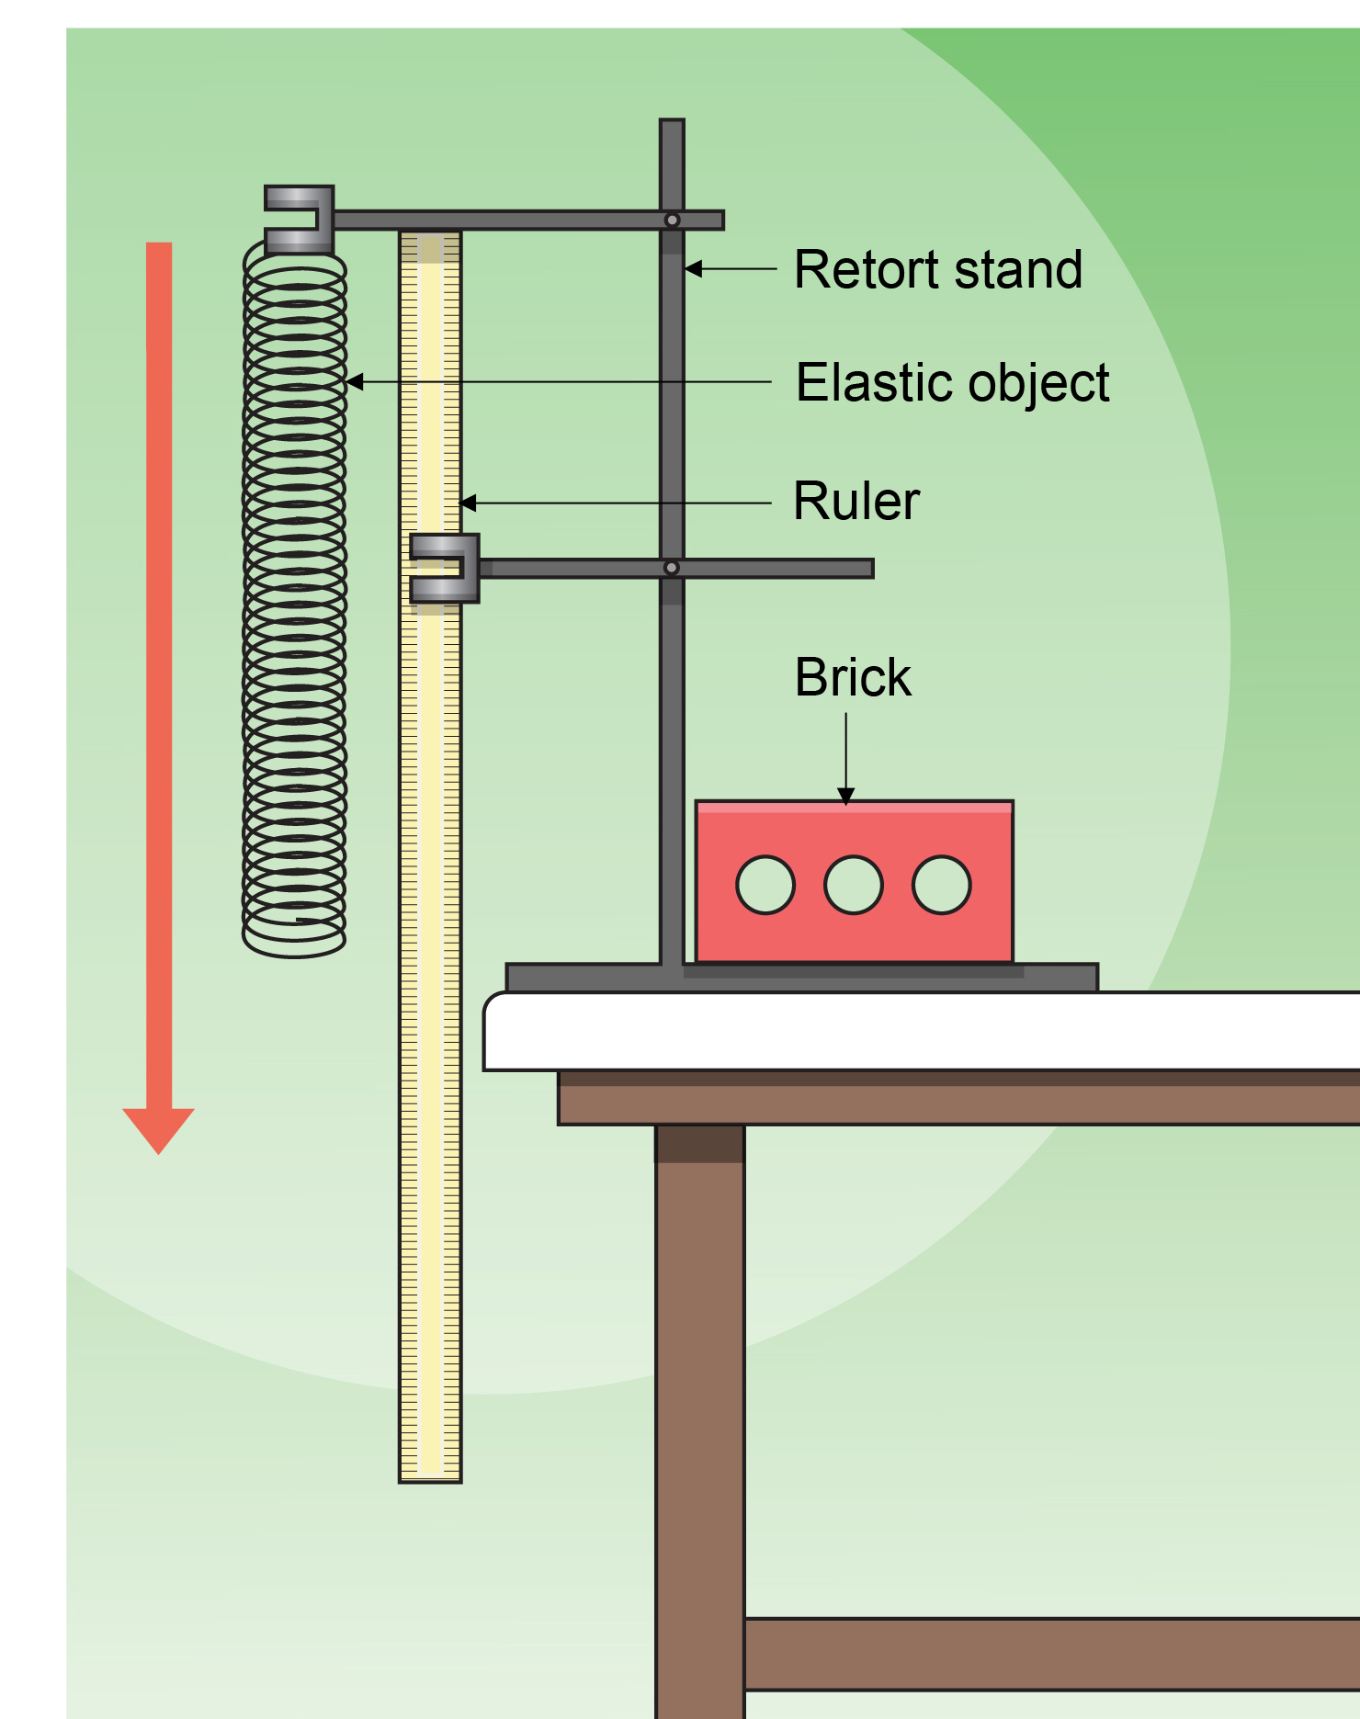
- Measure the length of the elastic band when extended, but not stretched. Remember this distance at the starting point for this rubber band.
- Hook the newton scale (spring balance) onto the bottom of the elastic band.
- Carefully pull the spring balance towards the floor until the elastic band has stretched a further 0.04 m, or 4 cm. Record the force on the spring balance.
- Repeat step 3, but record the force when the spring or elastic band has been stretched to 0.08 m, 0.12 m, and 0.16 m.
- Repeat steps 6–10 for two more different types of rubber band.
Part B – Calculating the Elastic Potential Energy, EPE
- Use the average spring constant value from table 2 to calculate the Elastic Potential Energy for each distance you stretched the rubber bands. Do this in table 3. Show all working in the space below
Working space for calculations

Part C – Measuring the Gravitational Potential Energy
- Place one end of the rubber band over the end of the metre ruller.
- Stretch the other end of the rubber band back 0.04m.
- Place the metre ruler on the ground with the rubber band end pointing vertically.
- Release the rubber band and measure the final height the rubber band reached. Subtract 1 m from this height and record in table 4.
- Repeat steps 1 to 4 three times, stretching the rubber band to 0.08, then 0.12m, then 0.16 m.
- Repeat steps 1 to 5 with the two other rubber bands.

Risk assessment  Fill in the table for the things in your experiment which may be a source of harm. Check with your teacher for some if you are not sure  / 2 | Risk assessment: Table 1 – Possible risks in experiment
  Source of risk | What amount of harm could it cause? (circle) | Safety precautions taken | If an incident occurred what should I do?
  Minor
  Significant
  major
  Minor
  Significant
  major
Results  Use the table on the right to collect the data when you stretch the rubber bands with the Newton scale (spring balance)  There is room (columns) to do three different rubber bands and the four stretch lengths.  The results in Table 3 will depend on the accuracy of your measurements here – so be careful.  /4  Draw a scatter graph (crosses for each data point) of:  Stretch distance (o.04, 0.08, 0.12, 0.16) versus force. This data is in Table 2.  Choose your scale carefully  You should have 4 data points (crosses) for each rubber band on your graph  Look at the 4 data points carefully. What pattern or “trend” do they make? Draw the trend line where you think the “trend” or “pattern” of crosses is.  You should have 3 trend lines – one fopr each rubber band. Show a key to indicate which line belongs to which rubber band.  The trend line does not have to go through all, or even any of the crosses.  / 5  Use the data collected in table 2 above to calculate the Elastic potential Energy for each of your rubber bands.  The formula is given in the table (column 1) and is also explained in the introduction. Look back there before asking your teacher for help.  /3  See the advice given for the last graph. A similar process should be used for this scatter graph. Use the EPE values in Table 3. Note the distance stretched in on the horizontal axis as it is now the independent variable.  /5  Measure the mass of each ruber band AND convert to kilograms (divide by 1000)  Follow the instructions in the method to shoot the rubber band into the air – as vertically as possible. Judge and measure the height reached by the rubber band – subtact a metre from you measurement.  For each height reached by the rubber band, calculate the Gavitational Potential Energy.  The formula is given in the table (column 1) and is also explained in the introduction. Look back there before asking your teacher for help.  /3  This table is really just for comparison of the two types of Energy. The data you need is from Table 3 (EPE data) and table 4 (GPE data)  /2 | Results  Table 2 – Measuements of vehicle motion down ramp.  The force and distance data from this table is shown graphically in graph1.  Graph 1: force applied at different stretch distances for 3 rubber bands  Distance stretched (metres, m)  Force appied to rubber band (Newtons, N)  Table 3 – Elastic Potential Energy in the rubber bands.  The Elastic Potential Energy and distance data from table 3 is shown graphically in graph 2.  Graph 2: EPE at different stretch distances for 3 rubber bands  Elastic Potential Energy EPE (Joules, J)  Distance rubber band was stretched (metres, m)  Table 4 – Gravitational Potential Energy in the rubber bands.  The following table compares the EPE for each rubber band when it is stretched and the GPE of each rubber band when it is released  Table 5 – Elastic Potential Energy and Gravitational Potential Energy for the rubber bands.
  Rubber band number | 1 | 2 | 3
  Description of rubber band
  Force to stretch to 0.04m (N)
  Spring constant, k
  (F / 0.04) (N/m)
  Force to stretch to 0.08m (N)
  Spring constant, k
  (F / 0.08) (N/m)
  Force to stretch to 0.12m (N)
  Spring constant, k
  (F / 0.12) (N/m)
  Force to stretch to 0.16m (N)
  Spring constant, k
  (F / 0.16) (N/m)
  Average Spring constant, k (N/m)
  Rubber band number | 1 | 2 | 3
  Description of rubber band
  EPE at 0.04m
  ½xkx0.04 (J)
  EPE at 0.08m
  ½xkx0.08 (J)
  EPE at 0.12m
  ½xkx0.12 (J)
  EPE at 0.16m
  ½xkx0.16 (J)
  Rubber band number | 1 | 2 | 3
  Description of rubber band
  Mass of rubber band (kg)
  Height, h reached at 0.04m stretch (m)
  GPE at 0.04m stretch
  mxgxh (J)
  Height, h reached at 0.08m stretch (m)
  GPE at 0.08m stretch
  mxgxh (J)
  Height, h reached at 0.12m stretch (m)
  GPE at 0.12m stretch
  mxgxh (J)
  Height, h reached at 0.16m stretch (m)
  GPE at 0.16m stretch
  mxgxh (J)
  Rubber band number | 1 | 2 | 3
  Description of rubber band
  EPE and GPE at 0.04m (J) | EPE =  GPE = | EPE =  GPE = | EPE =  GPE =
  EPE and GPE at 0.08m (J) | EPE =  GPE = | EPE =  GPE = | EPE =  GPE =
  EPE and GPE at 0.12m (J) | EPE =  GPE = | EPE =  GPE = | EPE =  GPE =
  EPE and GPE at 0.16m (J) | EPE =  GPE = | EPE =  GPE = | EPE =  GPE =
QUESTIONS  Think:  - What features of a rubber band allow it to store more EPE?  Think  - Use the two axis labels in your answer.  Think:  - How close are the four data points to each of the trend lines?  Think:  - There are two simple techniques scientists should use when collecting numerical measuments.  Think:  - Compare the EPE values for each rubber band with the GPE values for each rubber band. How close are they? Is there a general pattern?  If the EPE values are generally lower than the GPE, then some energy is being “lost”, where does it go?  If the values don’t form a pattern it is likely there is a significant amount of error in your experiment.  /10 | Questions.  - What was the highest Elastic Potential Energy stored in any of your rubber bands? ____________/½.  - Which rubber band and what amount of stretch caused the highest EPE? _______/½. Why do you think this rubber band and this amount of stretch caused the highest EPE ? ½ ____________________________________________________________ __________________________________________________________________________________________________________________________________________________________________________________/1  - Looking at graph 1:  - In one sentence describe the pattern or trend you see in the data. __________________________________________________________________________________________________________________________________________________________________________________________________________________________________________/2  - How accurate is your data in this graph? Explain why you think this.  _______________________________________________________________________________________________________________________________________________________________________________/2  - Are there some ways you could change the method so that your results would be more accurate? ______________________________________ __________________________________________________________________________________________________________________________________________________________________________________________________________________________________________/2  - The EPE stored in a rubber band should be all converted to GPE when the rubber band is shot vertically into the air. Is this what you observed? Explain. _____________________________________________________ __________________________________________________________________________________________________________________________________________________________________________________________________________________________________________________________________________________________________________________________________________________________________________________________________________________________________/2
Analysis  1St Section = Conclusions. (3 paragraphs as you have 3 main sets of data)  1st Paragraph - Write a sentence describing the relationship between the force applied to the rubber band and the distance it stretched.  Quote some data from the table or graph to support your logic. State if the pattern is true for all rubber bands you tested, and which one stretched the most.  2nd Paragraph - Write a sentence describing the relationship between the distance the rubber band stretched and the Elastic Potential Energy stored in the rubber band.  Quote some data from the table or graph to support your logic. State if the pattern is true for all rubber bands you tested, and which one stored the most EPE.  3rd Paragraph - Write a sentence describing the relationship between the Elastic Potential Energy stored in the rubber band and the Gravitational Potential Energy it was converted to.  Quote some data from the table or graph to support your logic. State if the pattern is true for all rubber bands you tested.  2nd Section = Errors  Firstly describe the amount of error in your experiment. Explain why you think there is “this amount” of error (often quote data or discuss graphs). Then explain how this error occurred, and finally propose recommendations to avoid this error.  3rd Section = Summation  Three sentences. One sentence about your main conclusion(s). One sentence about the error which occurred. One sentence outlining whether the hypothesis was proven correct.  /6 | ANALYSIS:  ____________________________________________________________________________________________________________________________  ____________________________________________________________________________________________________________________________________________________________________________________________________________________________________________________  __________________________________________________________________________________________________________________________________________________________________________________________  ________________________________________________________________________________________________________________________________________________________________________________________________________________________________________________________________________________________________________________________________________________________________________________________________________________________________________________________________________________________________________________  ____________________________________________________________________________________________________________________________  ______________________________________________________________  ________________________________________________________________________________________________________________________________________________________________________________________________________________________________________________________________________________________________________________________________________________________________________________________________________________________________________________________________________________________________________________  __________________________________________________________________________________________________________________________________________________________________________________________  ____________________________________________________________________________________________________________________________

